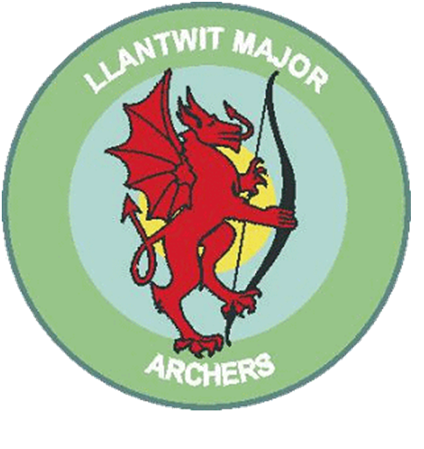
Llantwit Major Archery club

Adult Hoodies £21.00 each
A quality Hoody in black, complete with Llantwit Major Archers badge embroidered on the left chest.
Vinyl printed on the bow arm with Llantwit Major Archers. (Right handed archers will have the left sleeve printed, Left handed archers will have the right sleeve printed)

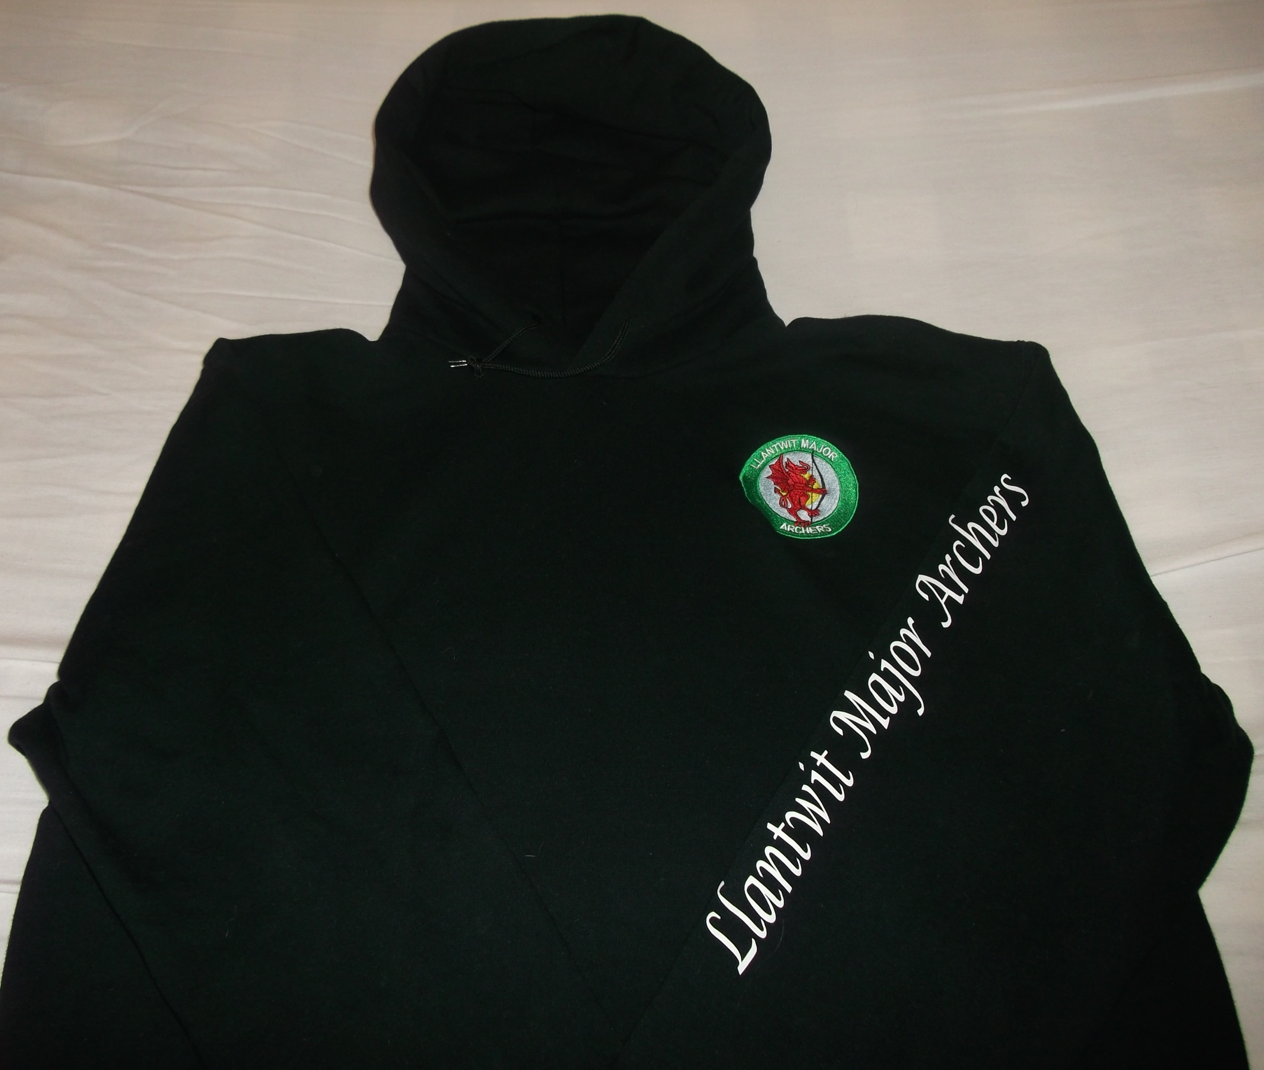

PLEASE ENSURE YOUR WRITING IS LEGIBLE!

Order Name
Size | To Fit | Quantity | L/R Handed | Cost
Small | 38” – 40”
Medium | 42” -44”
Large | 44”- 46”
XL | 46” – 48”
2XL | 48” – 50”
3XL | 50” – 52”
 |  |  | Total

Please make cheques payable to Llantwit Major Archery Club

